Current Account Questions
- The table gives the values of selected accounts in a nation’s balance of payments in millions of dollars.
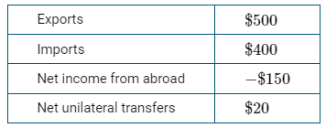
Based on the table, which of the following describes the balance in the current account and in the capital and financial account?
- The current account is in surplus.
- The current account is in deficit
- The current account is balanced.
- Which of the following is recorded in a country’s current account?
- The value of goods produced and consumed in the country
- The value of domestic financial assets sold to foreign investors
- The value of foreign bonds purchased by the country’s residents
- The value of consumer goods produced abroad and purchased by the country’s residents
- The value of the country’s government bonds purchased by the country’s central bank
- The table gives the values of selected accounts in a nation’s balance of payments in millions of dollars.
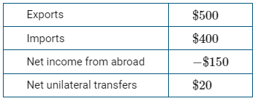
Based on the table, the nation’s trade balance is equal to which of the following?
- −$130 million
- −$100 million
- $100 million
- $770 million
- $900 million
- Which of the following transactions would increase the current account surplus in Japan’s balance of payments accounts?
- A Japan-based company sells roasted coffee to Canada.
- Mari, a Japanese investor, buys stocks in a Japanese company.
- Bob, a Canadian, buys stocks in a Japanese company.
- A Japan-based company buys a piece of equipment from Germany.
- Artois, a French citizen, works at a Japanese company in Paris.
- Which of the following would decrease the United States net exports to South Korea?
- South Korean computer companies sell more computers to the United States.
- South Korean insurance companies provide fewer services to the United States.
- South Koreans spend more vacations in the United States.
- United States banks provide more banking services to South Korea.
- United States smartphone companies sell more smartphones to South Korea.
- A country can have an increased surplus in its balance of trade as a result of
- an increase in domestic inflation
- declining imports and rising exports
- higher tariffs imposed by its trading partners
- an increase in financial capital inflow
- an appreciating currency
- Assume Country X has the following international transactions, in billions of dollars, during a given period of time.
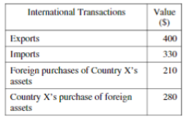
What is the balance on the current account, in billions of dollars, for the period?
- -140
- -70
- -0
- +70
- +140

Answers
1 | B | 6 | B
2 | D | 7 | D
3 | C | 8
4 | A | 9
5 | A | 10

